Задание 1  
SELECT

"Couriers".login,

COUNT("Orders".id) AS delivery_count

FROM

"Couriers"

JOIN

"Orders" ON "Couriers".id = "Orders"."courierId"

WHERE

"Orders"."inDelivery" = true

GROUP BY

"Couriers".login;  
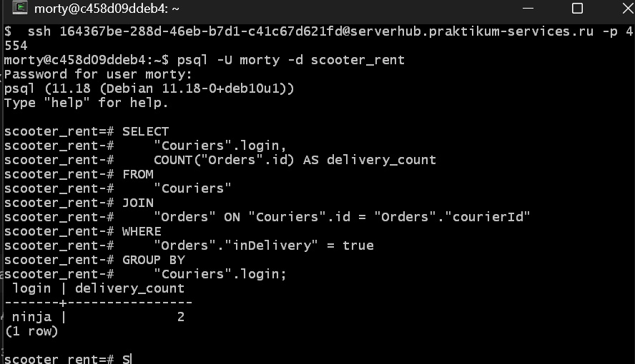

Задание 2  
SELECT

"track",

CASE

WHEN "finished" = true THEN 2

WHEN "cancelled" = true THEN -1

WHEN "inDelivery" = true THEN 1

ELSE 0

END AS status

FROM

"Orders";

